Quelle: The National, Abu Dhabi 17.07.2019

Cairo's Naguib Mahfouz Museum opens as homage to Nobel Prize for Literature winner
Mahfouz's 34 novels and hundreds of short stories are known for their incisive critique of Egyptian society and politics
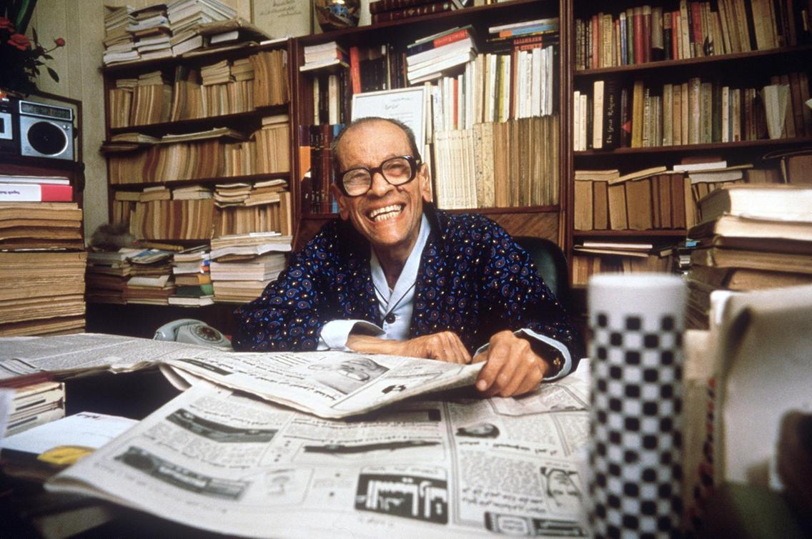
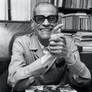
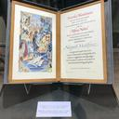
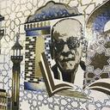
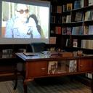
Egyptian novelist Naguib Mahfouz smiles in his Cairo home, 19 October 1988, a few days after the announcement of his award of the Nobel Prize in Literature. AFP
Renowned for his punctuality, Egypt’s only winner of the Nobel Prize in Literature to date, Naguib Mahfouz, would surely not have been pleased about the 11-year delay of the opening of a museum in his honour. The lengthy setback came to an end when the Naguib Mahfouz Museum was inaugurated on Sunday afternoon in the Al Azhar district of Islamic Cairo, close to where Mahfouz was born in 1911 and where many of his novels were set.
Mahfouz’s life, works and legacy are displayed on two floors in the historic Tkeit Abu El Dahab building, beside the Mohamed Bek Abo Dahab Mosque, which was established in 1774 during the Ottoman period in Egypt. The museum showcases the key works of the writer’s career, which spanned the decades encompassing British rule of Egypt, the country’s 1952 coup the1967 Arab-Israeli War, until Mahfouz’s death in 2006, at the age of 94.
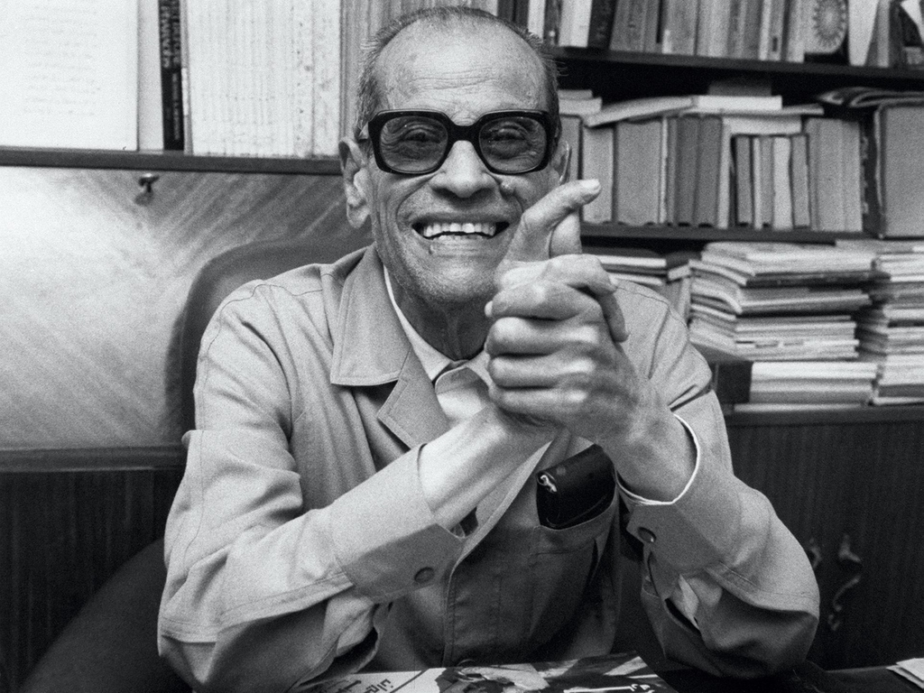Naguib Mahfouz by his desk in Cairo in 1988, obviously happy about his Nobel Prize for Literature. AFP
His 34 novels and hundreds of short stories, some of which were adapted for film, are known for their incisive criticism of Egyptian society and politics. One of his novels, Children of Gebelawi, originally published in serialised form in 1959 in state newspaper Al Ahram, was once banned in Egypt. It wasn’t until 2006 that the story was republished in the country.
Children of Gebelawi angered extremists in the country and was the catalyst for an attack on Mahfouz in 1994, during which he was stabbed in the neck while sitting in his car outside hisCairo home. The attack left Mahfouz with permanent nerve damage and he was only able to write for a few minutes a day for the rest of his life, greatly reducing his output.
In 1988, Mahfouz was awarded the Nobel Prize for Literature, making him the only Arab to receive the award so far. The award brought him international fame, while his work is seen as a benchmark for Egyptian literature. But his legacy was not collected in one place until the namesake museum opened this week.
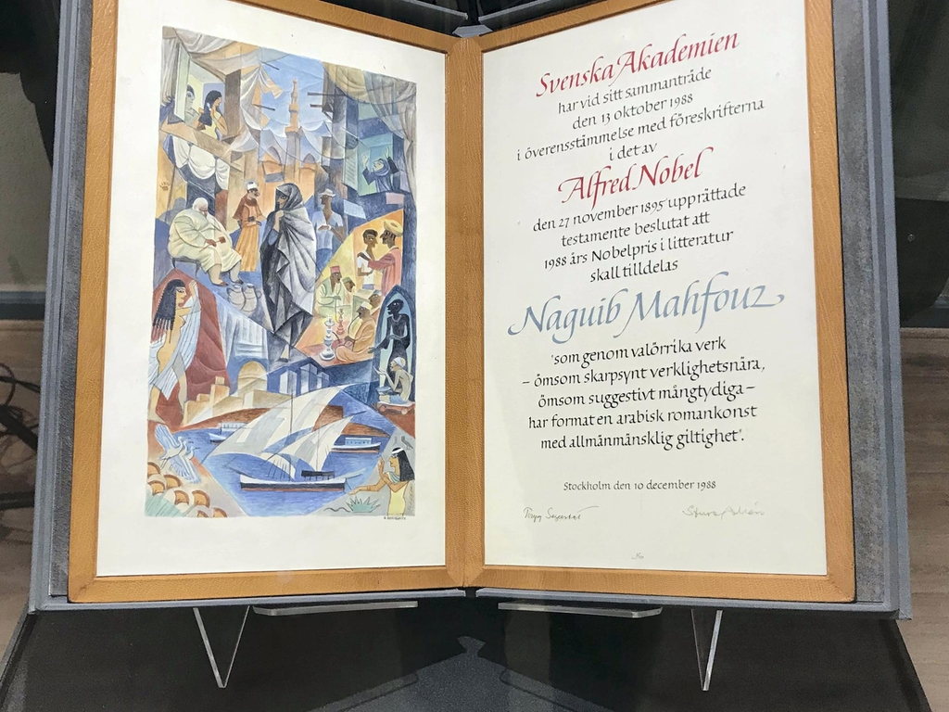Naguib Mahfouz's Nobel Prize in Literature certificate. Courtesy Walt Curnow
Dr Fathi Abdel Wahab of Egypt’s Cultural Development Fund, the organisation in charge of curating the museum alongside the country’s Ministry of Culture, says there were myriad reasons behind the long delay in the museum opening to the public.
“First of all, we had to be careful with how to fit everything in to the museum because it is a heritage building and it has to be done delicately,” he tells The National. “It’s difficult to get permission to do anything new inside palaces or old buildings.
“It was also difficult because of the revolution in 2011 and then the lack of co-ordination between various state bodies. But eventually, we have been able to co-ordinate and deliver the money we needed.”
The museum details the events of Mahfouz’s career and his life, starting with a section about where the writer was born and what effect the place had on his personality and writing. There is also a section about his education and displays of his belongings, as well as a section about the attempt to kill him and his later life.
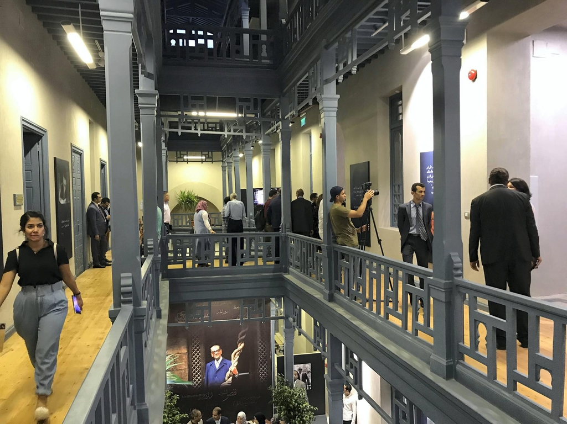A view of the museum from the second floor. Courtesy Walt Curnow
The museum also features rooms dedicated to movies that were either adapted from his novels, or for which he wrote the screenplays.
Karim Shaboury, a museographer who was in charge of the interior layout of the museum, also explains the difficulties of fitting out a museum in such an important piece of architectural heritage.
“The first challenge was working in an old, existing building where there are restrictions on what you can do because it is heritage,” he says, in a room filled with vintage posters of films with which Mahfouz was involved.
“The second challenge was how to introduce Naguib Mahfouz. The museum is not simply about displaying his production and literature but it also shows off his magical work for visitors and follows a layout plan that allows this. It required a lot of research.
It’s now a museum that has information that is easy to follow for everyone, both foreigners and Egyptians.”
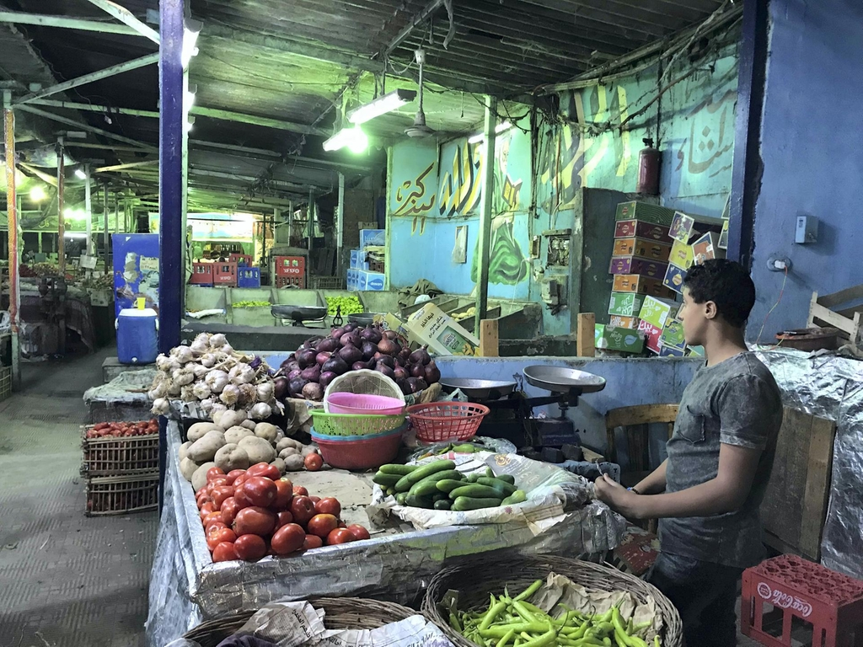A marketplace outside the museum, in the area of Islamic Cairo where Mahfouz was born and greatly inspired by. Courtesy Walt Curnow
While perhaps less visually appealing than the rest of the museum, his library, which was donated by the writer’s family, complete with colour photographs of Mahfouz and interactive video installations, offers a true insight into his life and the books he enjoyed reading.

READ MORE
25 years later, Naguib Mahfouz’s stories will finally see the light
Cairo's second-hand vendors boycott city's annual book fair over price hikes
Cairo Biennale returns after eight year hiatus with focus on diversity and
Abdel Hamed Mohamed Ali, from the libraries department at the Cultural Development Fund, says it took about five years to put together Mahfouz’s personal library of about 1,200 books, even with the help of his family. It’s a large collection of mostly Arabic literature featuring Egyptian writers such as Tawfiq Al-Hakim and Sonallah Ibrahim, as well as a large collection of books about philosophy and psychology. “By far you can see that he loved fiction the most, including quite a lot of foreign literature,” Ali says.
Among the selection of books published in English, there are a couple written by American novelist Jack Kerouac, a collection of works by William Shakespeare and a copy of Dubliners by James Joyce. There are also signed copies of books sent to Mahfouz by authors as gifts. Perhaps oddly, but indicative of his widespread international popularity and influence, is a signed copy of a novel by Brazilian author Paulo Coelho.
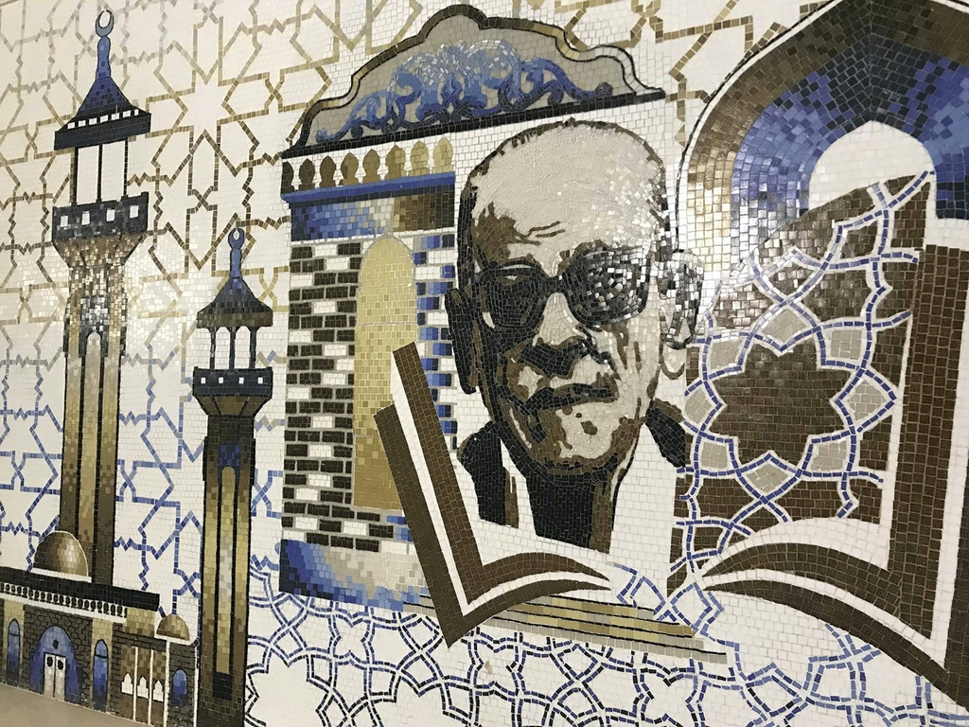A mural of Naguib Mahfouz outside the entrance to the museum on the street by Sohair. Courtesy Walt Curnow
On the street outside the museum, Sohair Osman, an artist and lifelong fan of Mahfouz, created a large mural of the author out of tiles, completing it in time for the museum’s opening. She says the value of the exhibits is primarily in showing tourists how much of an influential personality Mahfouz was in his homeland, as well as its educational value.
“The museum is also so important for Egyptian students because they now have such a large archive of his work and everything they need to know about his life that we didn’t have before.”

