Seven years of war.
A tragedy for Syria.
A catastrophe for the world
As the war enters its eighth year, here are eight reasons why we must make sure that this is its last
By The National staff and contributors
March 15, 2018
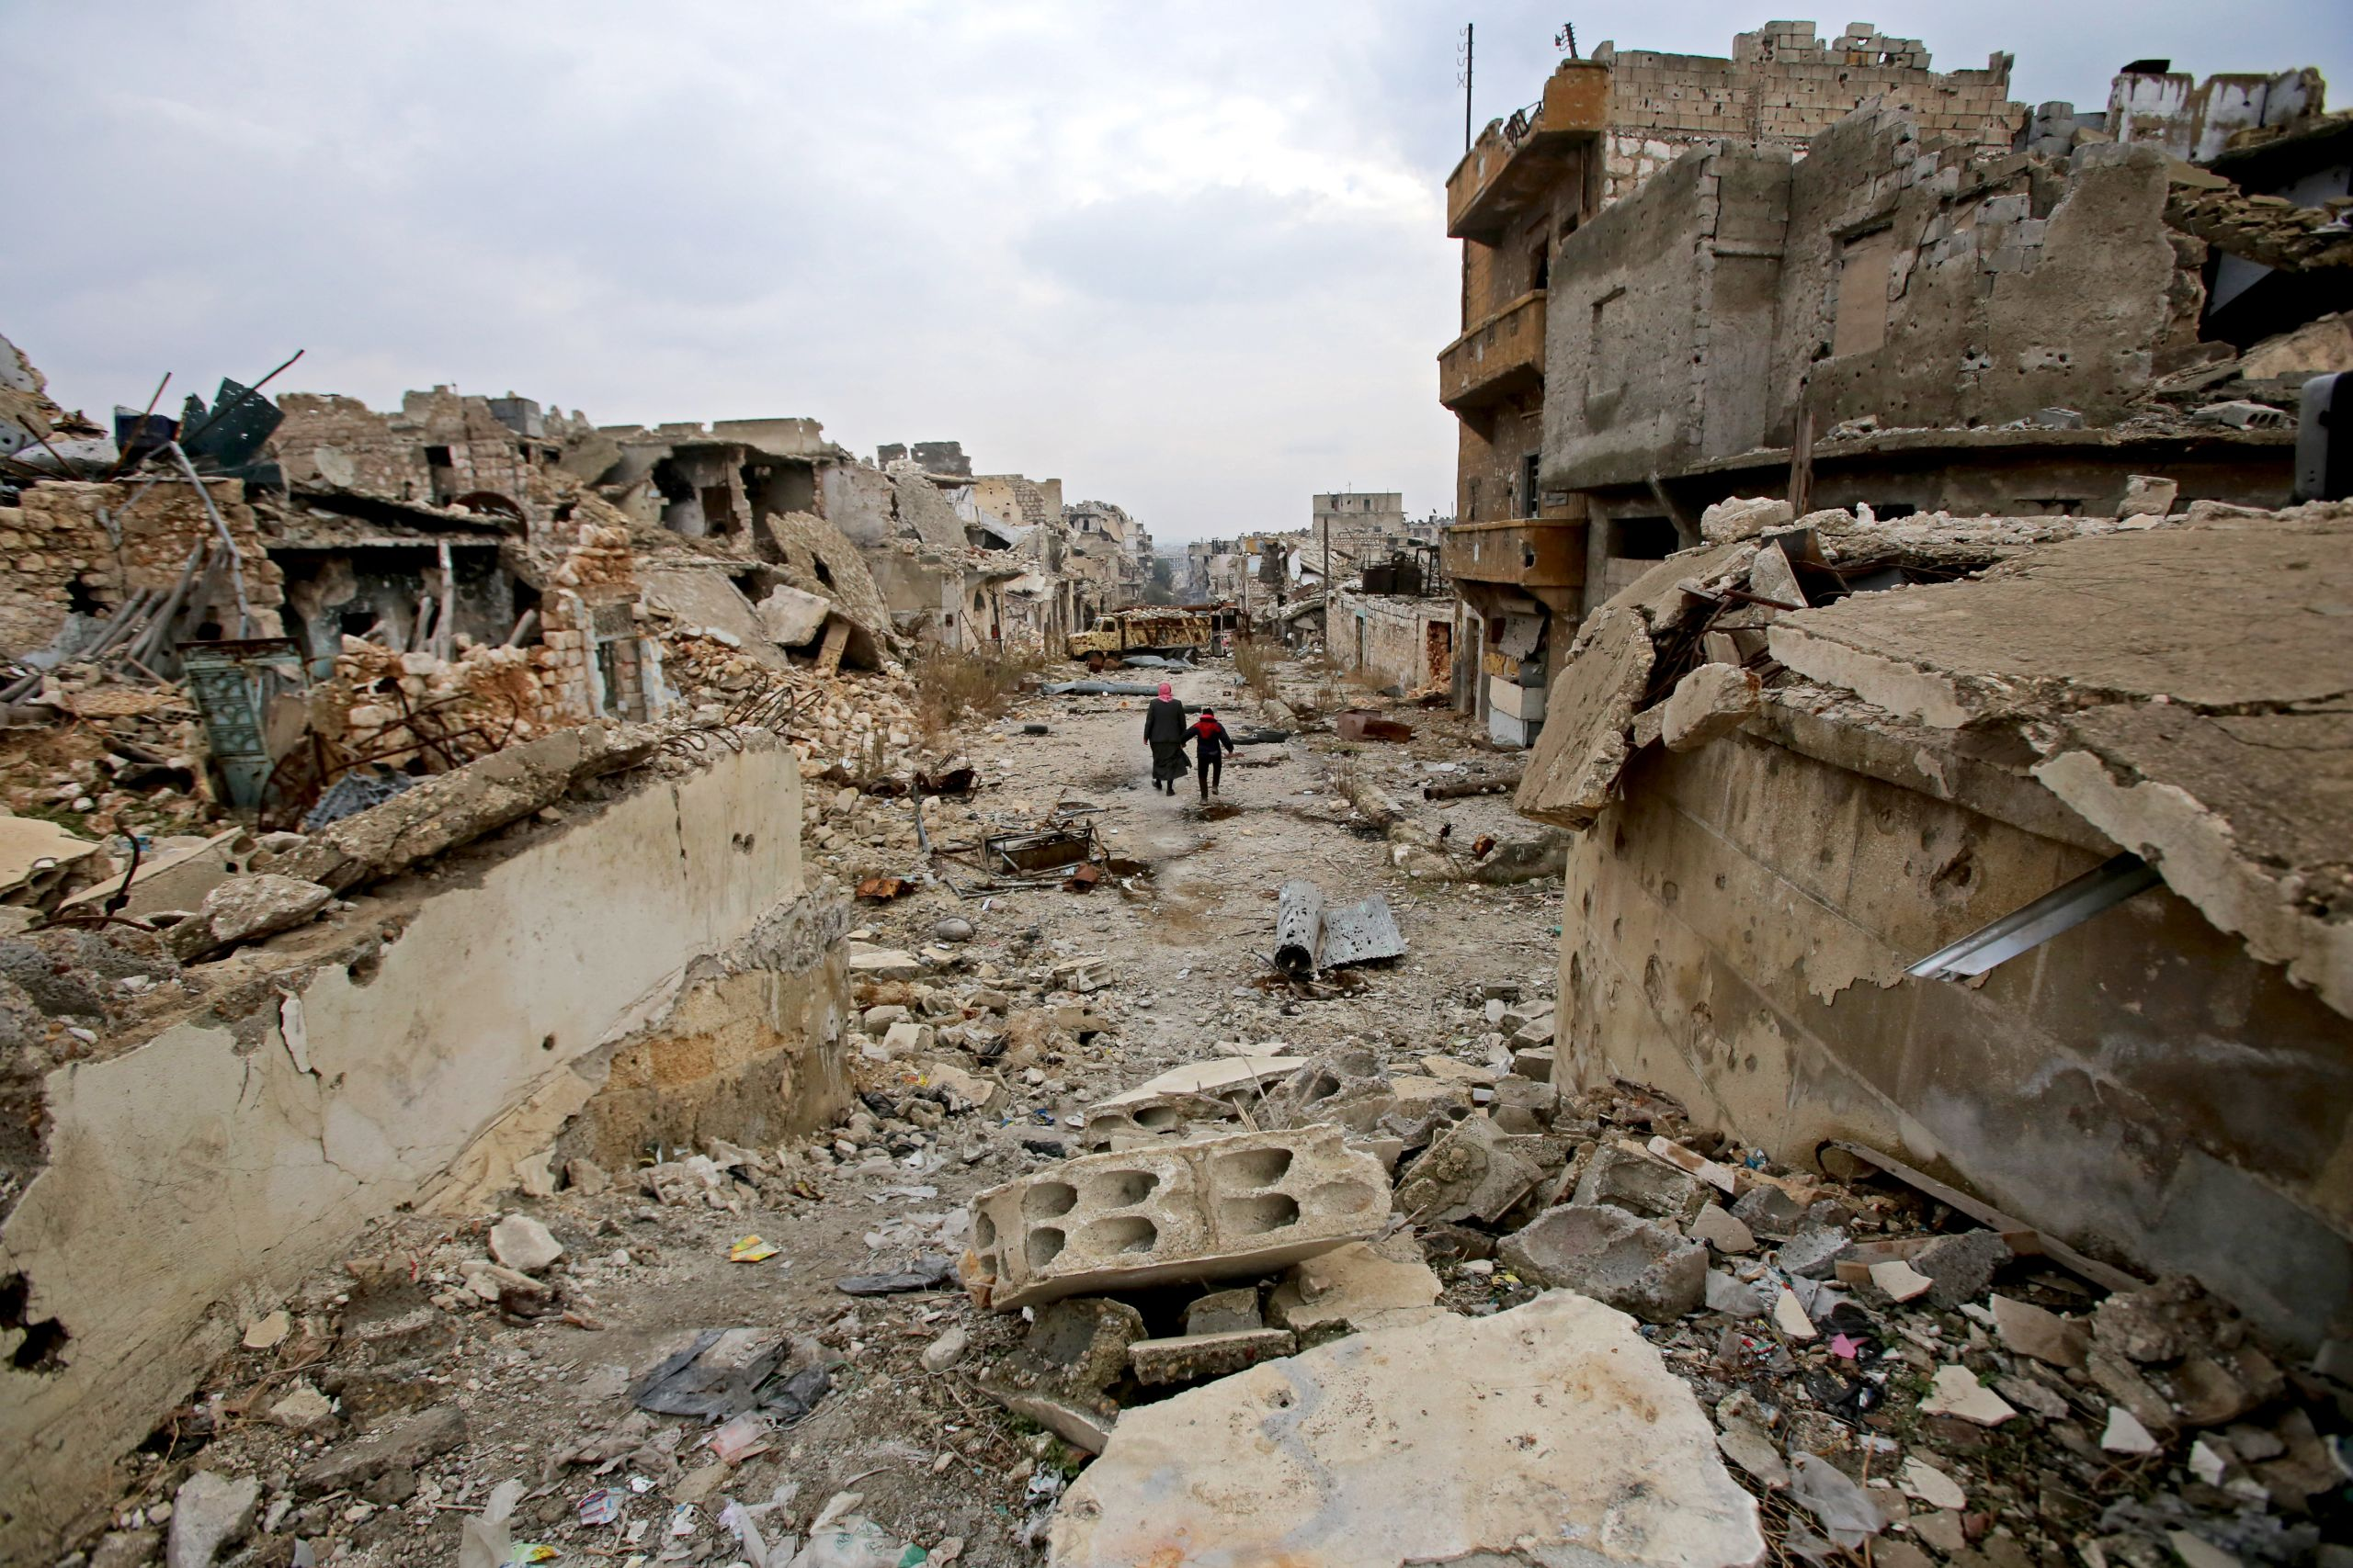
March 15, 2011: A "Day of Rage" is called in Syria to shake Bashar Al Assad’s regime, with ordinary Syrians demanding an end to corruption, nepotism and injustice. Seven years ago, each week of peaceful protests would be given a new name – "the uprising continues", "traders and revolutionaries, hand in hand until victory" – but as the weeks rolled into months and years, and as violence engulfed Syria, the names were dropped. Aspirations and dreams of an enlightened reform process led by Al Assad were defeated. The Day of Rage was met with brute force and the Syrian uprising turned into war.
Play
PlaySeek00:00Current time00:43Toggle MuteVolumeToggle Fullscreen
Early protests in 2011 (The National)
March 15, 2018: Entire areas in Syria are out of the regime's control, while others are under siege. Damascus is littered with checkpoints, occasionally struck by mortars to remind the Syrian regime that the opposition, while weak, is not dead. Iranian, Turkish, American and Russian soldiers and militiamen on the ground are embroiled in a regional war, with international impact, on Syrian soil. Political deals on de-escalation are struck in Sochi or Astana, with no Syrian representation.
Seven long years of war have had their toll on Syria and its people. The Arab world continues to feel the weight of that war. As Syrians sought refuge, a displacement of more than 13 million people has torn the fabric of society. A mass movement of more than 5 million people dispersed to neighbouring countries. A displacement – with more than half living in camps – not seen since Palestinians lost their homeland 70 years ago.
For those in Syria and abroad, the physical and mental traumas are compounded by the fact that no end is in sight.
They say that in war, the first victim is the truth. And with the rise of "fake news", the truth may seem to have died. Yet there are definite truths that cannot be ignored. Should not be ignored. More than half a million people have died. Two million Syrian children are out of school. Half of the country’s population is displaced. The governance system of the UN has failed and the principle of the "right to protect" has, in essence, been written off. Countless Syrians have died, been injured, lost loved ones, gone missing.
Journalists all over the world have borne witness to this tragedy. Some, like Khaled Al Essa and Marie Colvin, lost their lives to cast a light on this dark war. Our reporters and contributors explain here why the urgency to end it cannot subside because it has gone on for so long.
With the Syrian war entering its eighth year, this must be its last. Not only because it has resulted in the worst humanitarian crisis of this century – which should be enough reason – but because its repercussions on our international system are detrimental.
Mina Al-OraibiEditor-in-chief of The National

The utter devastation of Aleppo, seen in Reuters' photos before and after, below: the Old City in 2008 and then 2016, Sheebani School in 2009 and 2016, the Umayyad Mosque in 2010 and 2016

1. The insidious nature of chemical attacks

My clearest memory of visiting Khan Sheikhoun, two days after more than 80 people were killed in a toxic gas attack, was the graves.
Freshly dug red earth lined the tombstones. Abdelhamid Al Youssef, who had been receiving mourners at his home, teared up as he spoke of his wife and two children. He buried them on the day of the attack, hours after gas penetrated their home, suffocating the occupants. The faraway look on Abdelhamid’s face symbolised that his mind was elsewhere. In all, 20 members of his family were killed.
There is something particularly insidious about chemical attacks: the way the body betrays the victims; the way it upends expectations of safety by seeping into underground bomb shelters like liquid on cloth. Then there are the final paroxysms of death as the mouth foams and the end comes.
Sarin gas will choke you regardless of whether you are a civilian or a fighter, whether you don military fatigues or the uniform of the volunteer rescue workers. If you are a human, you will die or at the very least suffer. Poisoning the air is the ultimate tool of collective punishment.
In 2013 the Syrian government used sarin gas on the Ghouta region, killing more than 1,300 civilians in what remains the worst chemical atrocity of the war. The pictures of children in white shrouds haunted the world, and nearly prompted American intervention. President Barack Obama had said use of chemical weapons would be a red line for the United States.
Then, Secretary of State John Kerry, speaking off the cuff, said the American government could be placated if Al Assad gave up his entire chemical arsenal. Russia brokered a deal whereby those stockpiles were supposedly destroyed.
The sudden diplomatic shuffle, however, had a long-lasting effect: the Syrian regime appeared to draw the lesson that it could use anything against the population, except for chemical weapons.
Al Assad’s forces continued to use chlorine, a chemical that can be used in smaller doses to cause fear and suffocation without killing a lot of civilians. Chlorine was not covered under the deal brokered by Russia because it has industrial uses such as water purification, even though its use as a weapon is banned under international law. Between March and May 2015, opposition doctors and rescue workers said they documented at least 35 cases of possible chlorine attacks, with only nine deaths.
That pattern persisted until Donald Trump was sworn in as US president, vowing improved relations with Russia, which had intervened in the war in Syria, and hinting that the administration no longer regarded Al Assad’s departure as a priority. Soon the Syrian regime would test the administration’s tolerance by dropping sarin gas on Khan Sheikhoun in the early hours of April 4. Mr Trump responded by ordering 59 cruise missiles to be fired at the base from which the plane that dropped the sarin took off. Independent UN investigators and western intelligence agencies were able to reconstruct the details of the attack and link it back to the regime’s stockpiles.
There was little retribution beyond the isolated American strikes. The norms against chemical weapons use had been weakened. Despite renewed warnings from western powers, the Assad regime has reportedly used chemicals again in its continuing assault on the enclave of Eastern Ghouta, with attacks and symptoms bearing the fingerprints of chlorine or organo-phosphorous fertiliser used as weaponry. The ability of his forces to do so has highlighted that in an era of sophisticated warfare, ancient methods of killing are arguably the most devastating.
Kareem ShaheenContributor to The National based in Istanbul
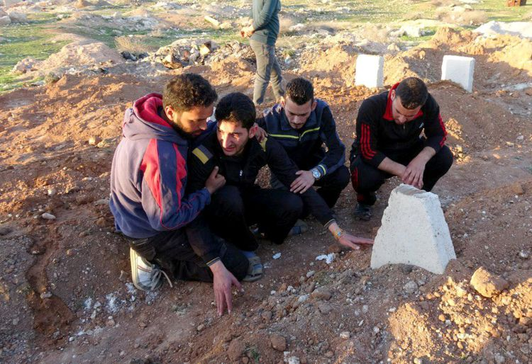
Abdelhamid Al Youssef, second from left, mourns over his wife and twin babies, killed in a chemical attack, at a cemetery in Idlib in April 2017 (Mohammed Al Daher/Anadolu Agency/Getty Images) Above, children are treated after a chlorine gas attack in Idlib in April 2017 (Getty Images)
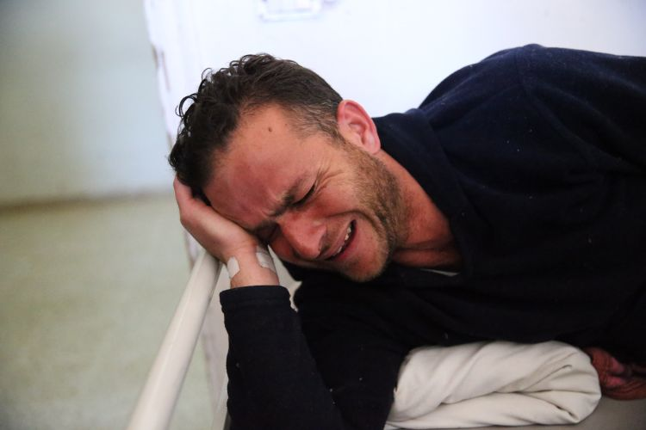
A survivor of the chemical attack in Idlib's Khan Sheikhoun town waits to receive treatment (Cem Genco/Anadolu Agency/Getty Images)

2. The vanishing red line

When it comes to evaluating Barack Obama’s presidency, the word Syria is usually judged negatively. Could he, and should he, have done more? The answer is almost certainly yes. What is less clear and less analysed is the wider question of whether there were any good options at his disposal.
Now, just as then, the effectiveness of military action was doubtful: Iraq had shown the limits of force. Mr Obama, after spending his first term pulling troops out of Iraq and Afghanistan, did not want to be dragged into a Middle East quagmire. And neither he nor the American public wanted yet more soldiers coming home in coffins draped in the Stars and Stripes. Such a prospect was very real and weighed heavily on the president’s decision-making on Syria.
Ultimately, however, it was Mr Obama’s own words that boxed him in. Having urged Bashar Al Assad to quit as early as 2011, his room for political manoeuvring was limited from the earliest days of the uprising. By the autumn of 2012, when the conflict had spiralled into a full-blown civil war, Mr Obama was under pressure to act militarily. The factor pushing him towards intervention was growing evidence that the Syrian regime was mobilising a chemical and biological weapons arsenal that could be used against civilians.
“A red line for us is we start seeing a whole bunch of chemical weapons moving around or being utilised. That would change my calculus,” Mr Obama said.
Play
PlaySeek00:00Current time00:49Toggle MuteVolumeToggle Fullscreen
When Obama raised the 'red line' (C-SPAN)
That statement, more than any other, is likely to haunt him. With the war now entering its eighth year it seems extraordinary that it was not until 12 months later that the president would be held accountable for the remarks. The Assad regime’s purported use of the nerve agent sarin in the Damascus suburb of Ghouta in the early hours of August 21, 2013, in which hundreds – maybe as many as 1,200 people – were reportedly killed, could not be ignored.
A military option was on the table but Britain was part of the plan. Politicians in London, suffering from an Iraq hangover, voted against taking action against Al Assad. Mr Obama stalled, plagued by doubt and mindful of how his predecessor George W Bush’s invasion of Iraq was undermined because of a lack of international support. He asked Congress for its approval of military action.
That delay added to the perception that the president was dithering, such was his belief – or rather more likely the lack of it – that Al Assad could be toppled or forced to stand down in the face of a US military onslaught. The red line on chemical weapons had been crossed.
'A red line for us is we start seeing a whole bunch of chemical weapons moving around or being utilised. That would change my calculus'US President Barack Obama
But Mr Obama’s calculus did not change. A hasty deal was instead put together by Russia and the US under which the Syrian regime’s chemical weapons would be taken out of the country. A succession of attacks have followed, many using chlorine gas, which was not included in the substances removed.
Less than six years after the red line was drawn, and with a death toll of more than 500,000, it is unarguable that Mr Obama did not follow through on his threat of force in Syria. It is a palpable example of the adage that saying you will do something is not the same as doing it, even when you are president of the US.
Today, it seems questionable if Al Assad’s removal is even desirable. There has never been an American or international plan for a new Syrian administration that had a chance of being delivered, given the Middle East’s shifting alliances. Mr Obama, a wordsmith of the highest order, erred.
It would also be wrong to compare his mistakes – chiefly, his inaction – with those of Mr Bush, whose errors were actions born from a lack of restraint and evaluation. But the costs are no less real. Mr Bush has never expressed regret for Iraq but Bill Clinton, after leaving office, administered a personal reckoning by saying he failed to stop a genocide in Rwanda. When Mr Obama’s memoirs – he signed a deal this month – are published we may see if his judgment on Syria is something he stands by.
Arthur MacMillanForeign editor of The National
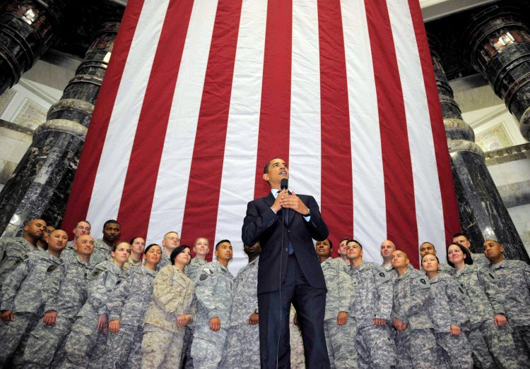
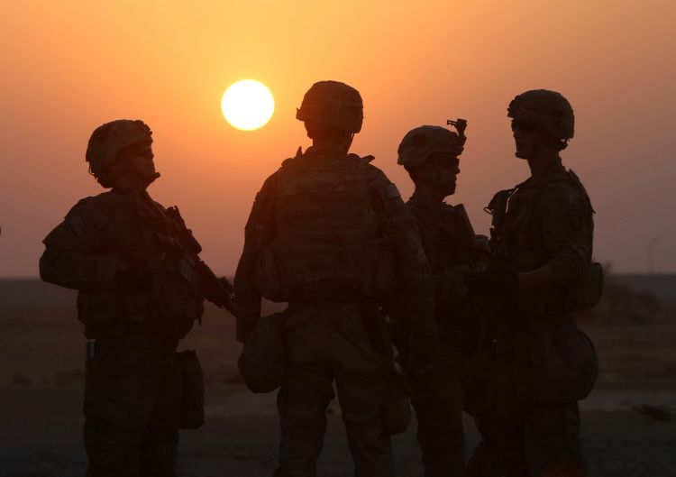

3. Death toll:
half a million and counting

The number of civilians killed in the besieged enclave of Eastern Ghouta since February 18 might be 1,100, if you believe the Syrian Observatory for Human Rights. Doctors Without Borders said it crossed 1,000 on Friday. The local health authority says it is well over 1,300.
It is hard to be sure how many have died during a relentless aerial and artillery bombardment of the area, once the breadbasket of Damascus, where at least 300,000 people still live. That is because many are still (and might always be) under the rubble of their destroyed homes. Some are buried by their families immediately after they are recovered, rather than taken to hospitals where they would be added to the death toll.
It is a striking fact that despite knowing 200 people have probably been killed, it is the circumstances of their death that has precluded them from being counted. After terrorist attacks around the world, personal stories of those prematurely robbed of their lives are often circulated and retold with images of them smiling, so that the victims do not become a mere number.
Syrians have long lost the luxury of being counted.
The UN stopped counting civilian casualties in Syria in late 2013 after the death toll passed 100,000. It said it could no longer reliably verify figures it was receiving from various sources. The UN’s special envoy on Syria, Staffan de Mistura, said in April 2016 that his estimate of the casualties was 400,000, while the Syrian Centre for Policy Research said it was as high as 470,000. The Syrian Observatory for Human Rights said on Monday that the figure was 511,000, including fighters on all sides of the conflict.
The lowest death toll is by the Violations Documentation Centre, which has identified 160,247 dead because it often tries to find out their names and publish them on the database.
They have been killed by various deliberate means: air strikes, shelling, suicide bombs, barrel bombs, sarin gas, explosive weapons and mines, incendiary armaments, gas cylinders used as mortars, sniper fire, machineguns, and by burning, drowning and beheading.
All of the figures are probably underestimates. They do not include those who have died under torture in the notorious prisons of President Bashar Al Assad’s regime, or who were made to disappear by ISIL in its reign of terror that captured part of the country in 2014. They do not include those who starved to death under medieval sieges, or were felled by chronic illnesses such as diabetes or kidney failure because the lack of medical supplies under blockade meant they could not have dialysis machines or pills that would aid their survival.
No one knows how many bodies remain unclaimed under the rubble of homes that caved in during the last desperate weeks in the siege of Aleppo. And there is no count of those buried under the cement that once stood as their homes before the shelling in Eastern Ghouta.
In neighbouring Lebanon, 17,000 people who disappeared during the country’s 15-year civil war remain missing, many in Syrian government prisons. Their families still gather at the tent of the disappeared outside the UN offices in Beirut, 35 years after their first meeting. As long as there are no answers, the wounds will fester and there will be no closure.
Despite the sheer carnage and the scale and length of civilian suffering in Syria, which has often prompted what aid officials describe as donor and audience fatigue, the name of a child that accompanies an image of her dusty face after death is always a slap in the face. The name is a reminder of a life unlived, of dreams yet to be born that were cruelly crushed under the heel of a thermobaric missile or the shrapnel of a barrel bomb.
But if the dead remain at the very least uncounted, when the guns finally fall silent in tortured Syria, will all those ghosts be at rest?
Kareem Shaheen
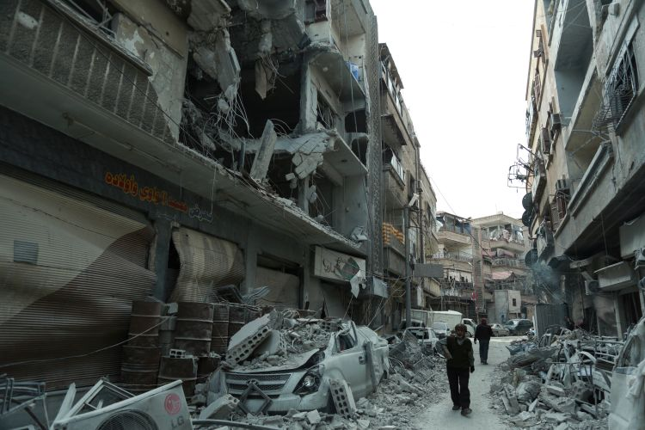
What the rebel-held town of Douma in Eastern Ghouta looked like earlier this month (Hamza Al-Ajweh/AFP) Above, members of the White Helmets carry a civilian on a stretcher after an air strike on Saqba, Eastern Ghouta, February 2018 (Abdulmonam Eassa/AFP)
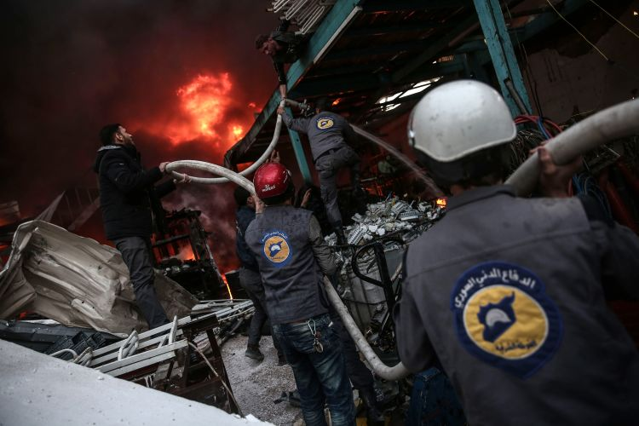
Members of the White Helmets extinguish fire after an air strike in Douma in 2016 (Abdulmonam Eassa/AFP)
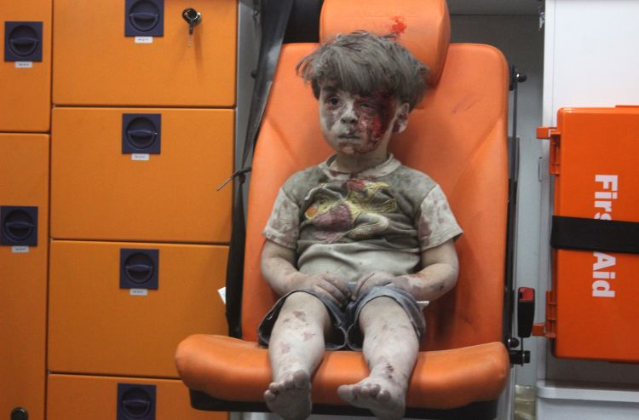
Omran Daqneesh, 5, wounded in an air strike on Aleppo in 2016, became a symbol of civilian suffering (Mamud Rslan/Anadolu Agency/Getty Images)
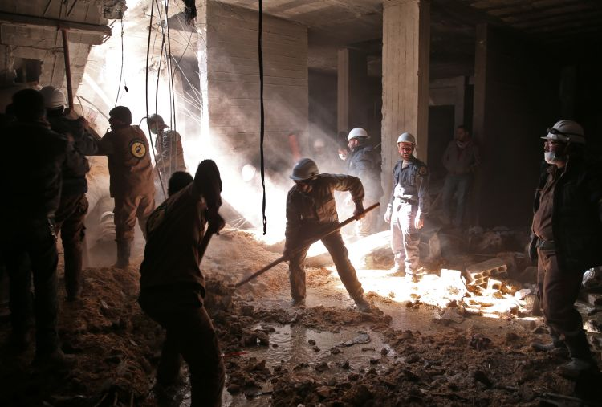
The White Helmets search for survivors after an air strike on the Damascus suburb of Al Qaboun (Msallam Abdalbaset/AFP)
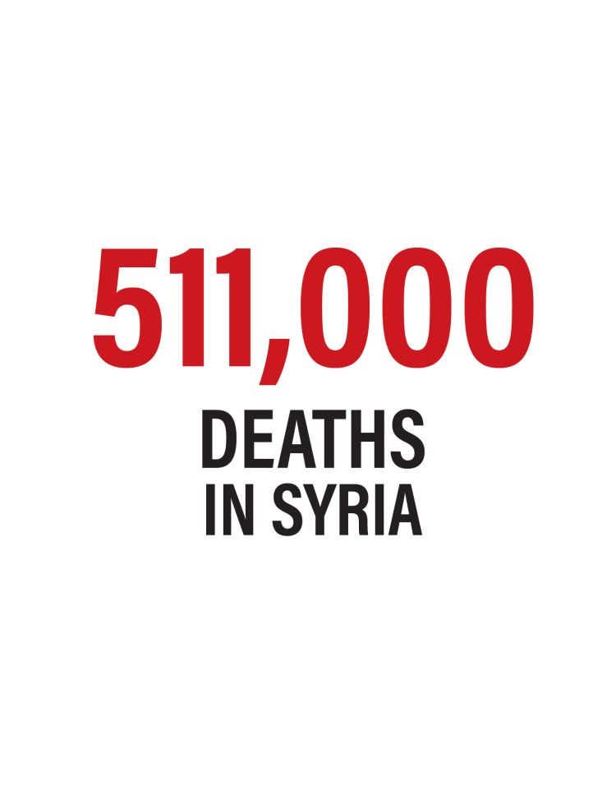
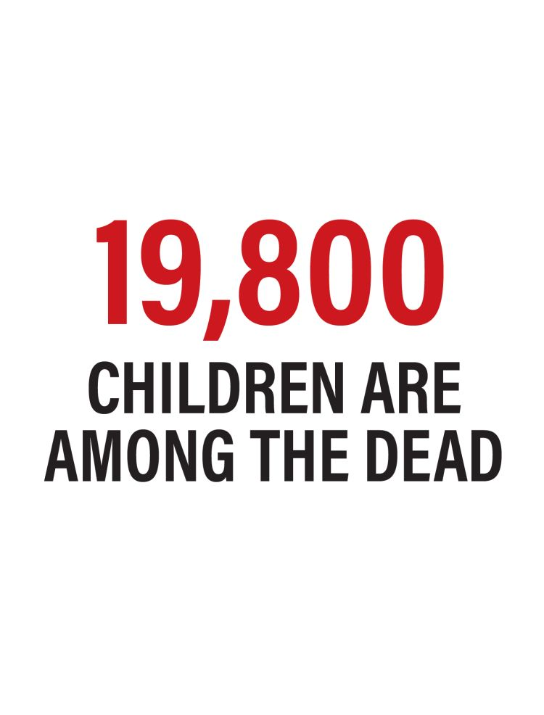
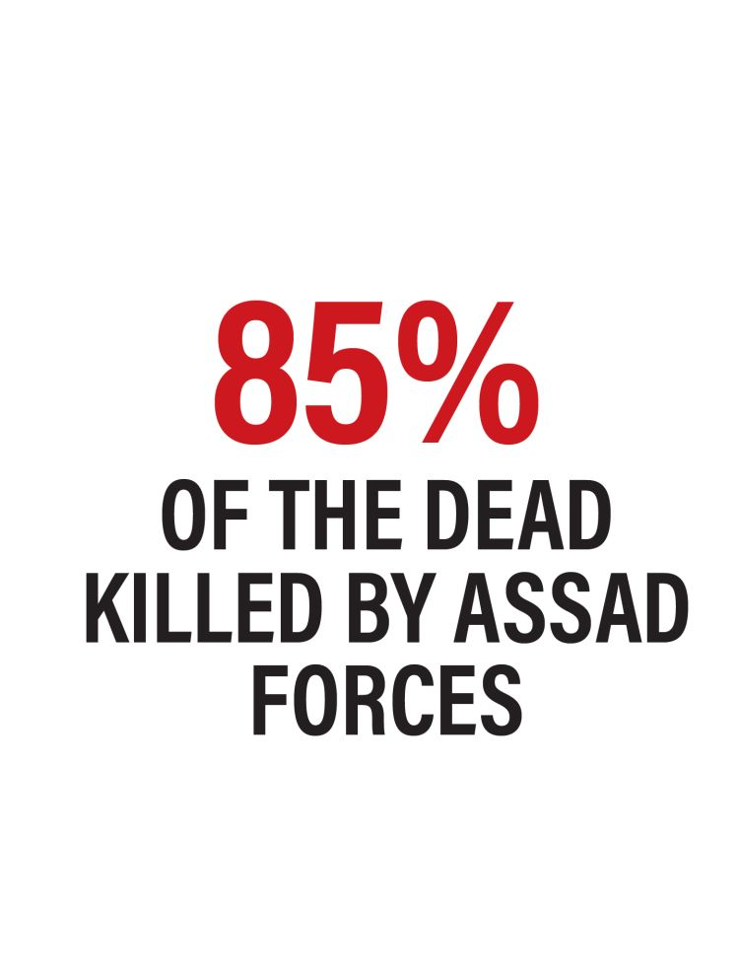

4. The unbreakable
Bashar Al Assad

One of the overlooked features of Syria’s brutal civil war has been the remarkable resilience shown by President Bashar Al Assad to survive in power.
When anti-government protests erupted throughout the country in March 2011 as part of the Arab uprisings, very few observers believed Al Assad could survive.
Widely regarded as a weak man who had gained the presidency by default, the softly spoken occupant of the presidential palace in Damascus seemed set to suffer the same fate as the rest of the region’s secular dictators.
I remember attending an intelligence briefing on the internal political dimensions of the Assad regime right at the start of the conflict. The general consensus was that were it not for the die-hard support of the minority Alawite community and the more robust members of the Assad clan, regime change of some sort was inevitable.
During the early years of the conflict, that appeared to be very much the way it was going. Despite attempts by the president’s brother Maher Al Assad to mobilise loyalist sections of the armed forces, such as the predominantly Alawite Fourth Armoured Division, the momentum was clearly with the rebel groups, who became better organised while attracting the support of regional benefactors.
The most graphic illustration that the tide of the conflict was moving in the rebels’ favour came in the summer of 2012 when a bomb destroyed the regime’s national security headquarters in Damascus, killing the defence minister and his deputy, as well as other high-ranking officials.
The growing effectiveness of the rebel groups, together with the gradual erosion of domestic support for Al Assad, meant that by the summer of 2015 it looked more a case of when he would be removed from power, not if. The diplomatic world was awash with rumours that he would be offered a safe haven in Russia in return for leaving office and bringing the conflict to an end.
The fact that Al Assad today seems more in control of his country than at any point in the conflict’s seven-year history, and is able to use chemical weapons against rebel groups in the Eastern Ghouta suburbs of Damascus with impunity, represents a major turnaround in the Syrian dictator’s fortunes that, in retrospect, can be attributed to several key factors.
One was the Obama administration’s decision to back down on its threat to launch military action against the Assad regime in 2013 over the use of chemical weapons. Mr Obama’s betrayal of the rebel cause was, in part, motivated by then British Prime Minister David Cameron’s failure to win parliamentary backing for British participation in such action.
This sent a clear signal to Al Assad that the outside world was not serious about intervening in the conflict, giving him free rein to maintain his assault on his own people.
Another key factor was Russian President Vladimir Putin’s decision to intervene on behalf of the regime two years later in September 2015, which was a reaction to Mr Obama’s change of heart. The Russians were persuaded to intervene after a visit to Moscow that summer by Qasem Suleimani, the head of the Iranian Revolutionary Guard’s Quds Force, who persuaded Mr Putin that Russia would lose its prized military bases in Syria unless it acted to save Al Assad.
The ruse worked, and the combination of Russian air power and Iranian involvement in training pro-regime militias was central to turning the tide of the conflict in Al Assad’s favour. As the conflict enters its eighth year, the Assad regime’s ultimate victory now appears all but assured.
Con CoughlinColumnist for The National and the Daily Telegraph’s defence and foreign affairs editor

In the graphic below, see how Bashar Al Assad's regime lost and then managed to regain control over much of the country
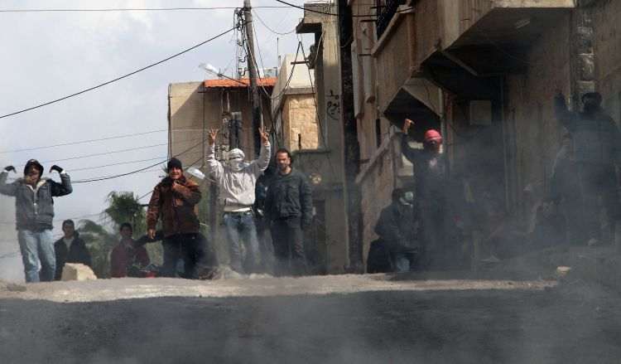
Protesters on the streets of Daraa, south of Damascus, on March 23, 2011 (Anwar Amro/AFP)
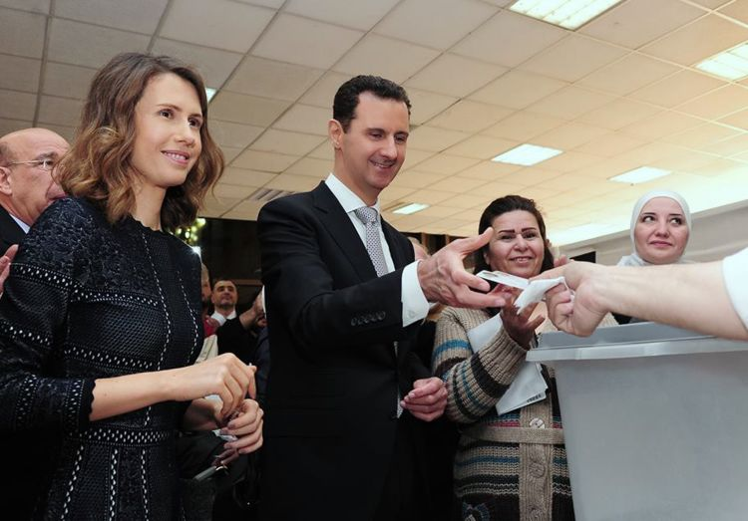
Syrian President Bashar Al Assad and his wife Asma vote at a polling station in Damascus during parliamentary elections in 2016, dismissed by the opposition as illegitmate (AFP)
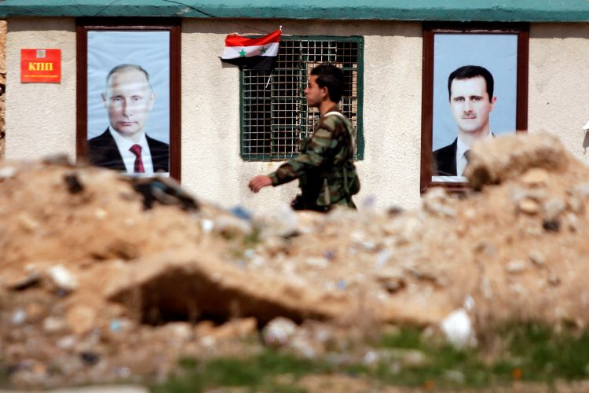
A Syrian soldier loyal to the regime is seen outside Eastern Ghouta last month (Omar Sanadiki/Reuters)

5. A refugee crisis unparalleled since the Second World War

Syria has shown empathy to be a fleeting emotion. For the country’s ever-growing refugee population, the feeling peaked in the summer of 2015 when the body of three-year-old Aylan Kurdi washed up on a Turkish beach, his knees tucked underneath him. Carried away wearing only a tiny T-shirt and shorts, his death reminded parents across the world of their good fortune in having their children safely asleep in their beds.
Nearly a year later, in July 2016, the father of a young French boy killed in a terror attack in Nice recalled that his lifeless son “looked like Aylan, the little refugee”. And in that one sentence, the father recognised that in grief we are all equal.
By then it was rare to hear such an acknowledgement of shared experience with refugees. Much more common was a barrage of invective blaming refugees for all of the world’s troubles. Attacks such as those in Paris and Nice were used as an excuse to close the doors to those in need. During the abysmal summer three years ago, when hundreds of thousands of desperate people fell out of boats on the Greek islands and set off across Europe in search of safety, opportunistic politicians were quick to realise they had an easy scapegoat. With xenophobic speech largely unchallenged by mainstream politicians, hate and suspicion has been allowed to flourish.
When I wrote a book about the refugee crisis in 2015, I hoped by telling the stories of real people forced to flee to Europe that I could break down the barrier between “us” and “them”, and show how much the new arrivals have in common with their hosts. But seven years on from the start of the Syrian conflict, empathy for its refugees is hard to find.
In the past few weeks a political alliance in Italy, which ran on a platform to deport 600,000 migrants and asylum seekers, won the largest share of the vote. Hungary’s Prime Minister Viktor Orban – expected to be re-elected next month – is championing a law punishing NGOs that assist refugees. And as rockets fell on Eastern Ghouta last week, politicians from Germany’s far-right AfD party, which won its first parliamentary seats in recent elections, sat with regime officials in Damascus to discuss whether Syria could be declared a safe country to repatriate people.
What does all this mean for the 5.6 million Syrians forced out of their homes? More anguish and uncertainty, wherever they end up.
Most Syrian refugees are living a precarious existence in Turkey, which is hosting 3.5 million. Lebanon, a tiny country of only a few million, is home to almost 1 million Syrians, while Jordan, Iraq and Egypt also host large numbers. But as the conflict grinds on, resentment in all these nations has grown, particularly as host governments spend large sums on refugees while the international community is better at platitudes than concrete offers of help.
The portents are dire. Almost half of Syrian refugee children are not in school, UN figures show. And most refugees live below the poverty line, struggling to get the basics for survival: food, medicine and shelter. The UN has had to cut aid across the region after their 2017 appeal was only half funded. Its officials have warned that many more refugees may try and travel to Europe if nothing changes.
But no one seems to be listening.
“I don't really think the world has forgotten about us but it feels more like no one cares any more,” says Rim Hamzeh, a 27-year-old teaching assistant whose journey from student protester in Damascus to refugee in Norway is featured in my book.
This does not mean that there is no compassion to be found. For every tub-thumping populist, there is a Facebook group with citizens rallying to help their refugee guests, a mayor with a progressive integration scheme, or a crowdfunding campaign to reunite a fractured Syrian family. But such voices seem to be drowned out by hate.
The one million or so Syrians who have made it to Europe face a broken asylum system designed to keep people out. A morally dubious deal allows the EU to return asylum-seekers who arrive by boat to Turkey. Another agreement to relocate refugees from Greece and Italy to elsewhere in the EU ended last September with only 27,000 of the promised 160,000 refugees moved from over-crowded centres in the two countries. Hate crime is on the rise, funding for integration dwindles and governments devise more pretexts to refuse applications. The gap between declarations and delivery has been stark. The EU holds itself up as a beacon of human rights and tolerance for the rest of the world. But when it comes to Syria’s refugees, it is setting the bar very low.
Charlotte McDonald-GibsonAuthor of Cast Away: Stories of Survival from Europe's Refugee Crisis
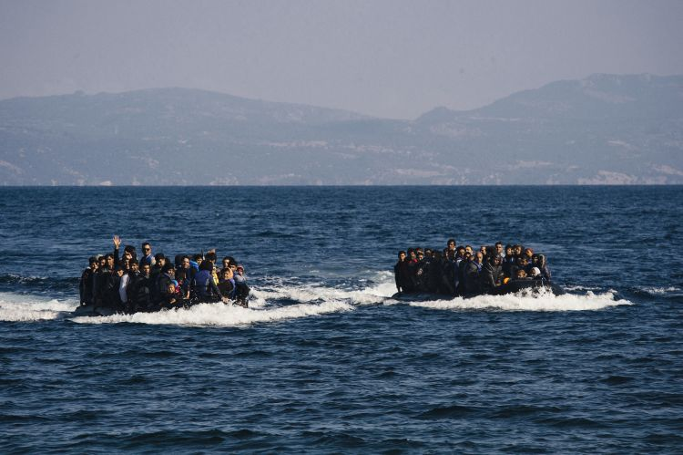
Migrants arrive by boat on the Greek island of Lesbos in 2015 (Dimitar Dilkoff/AFP)
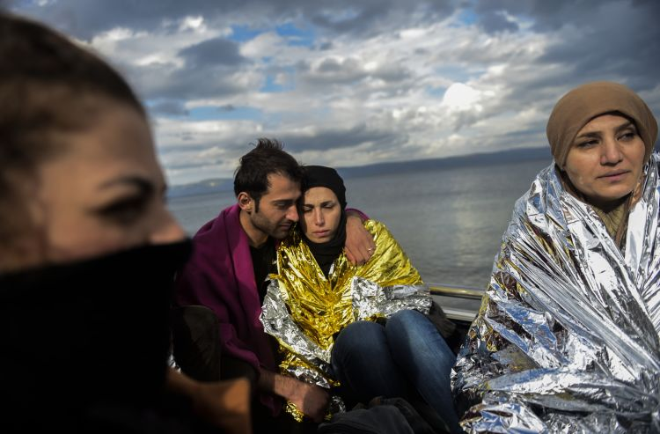
Migrants wait for aid on Lesbos in 2015 (Bulent Kilic/AFP)
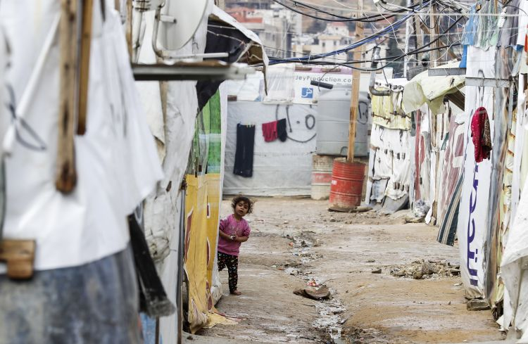
A Syrian girl in a refugee camp on the outskirts of Zahle in Lebanon's Bekaa Valley in January 2018 (Joseph Eid/AFP)
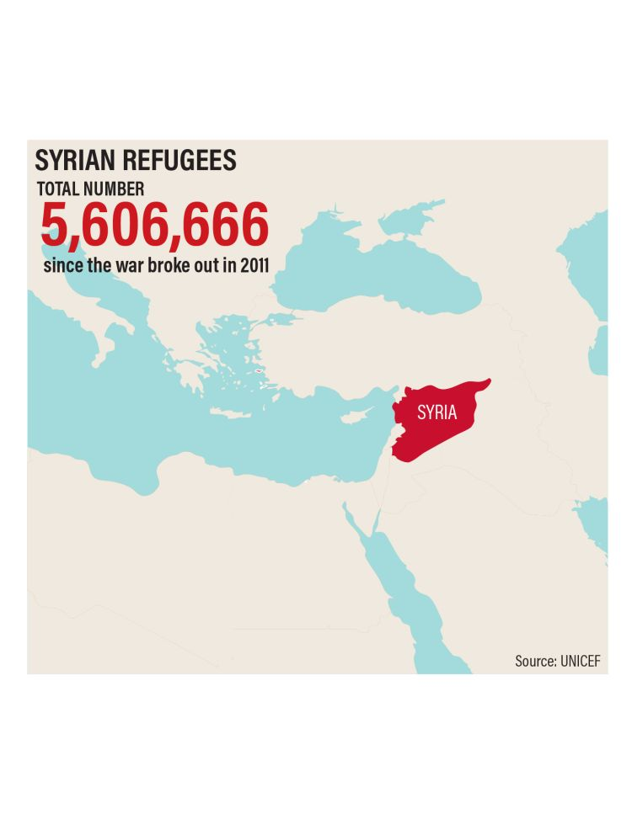
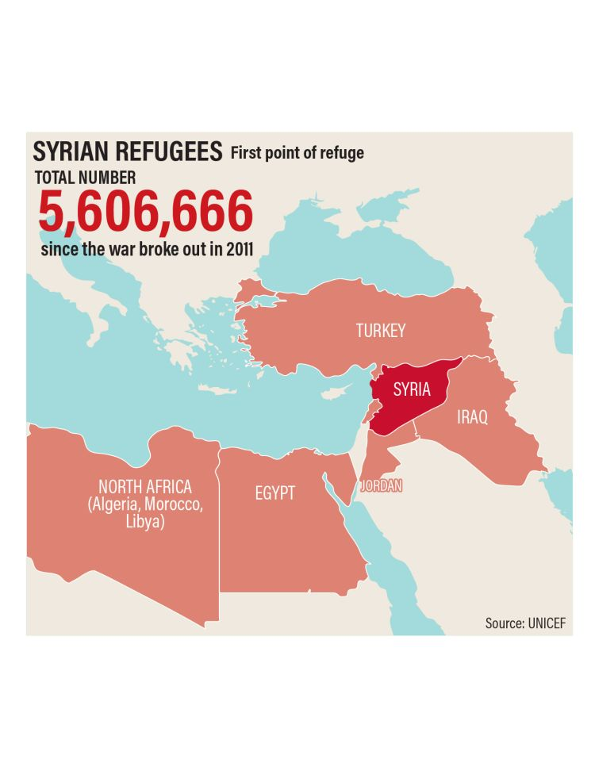
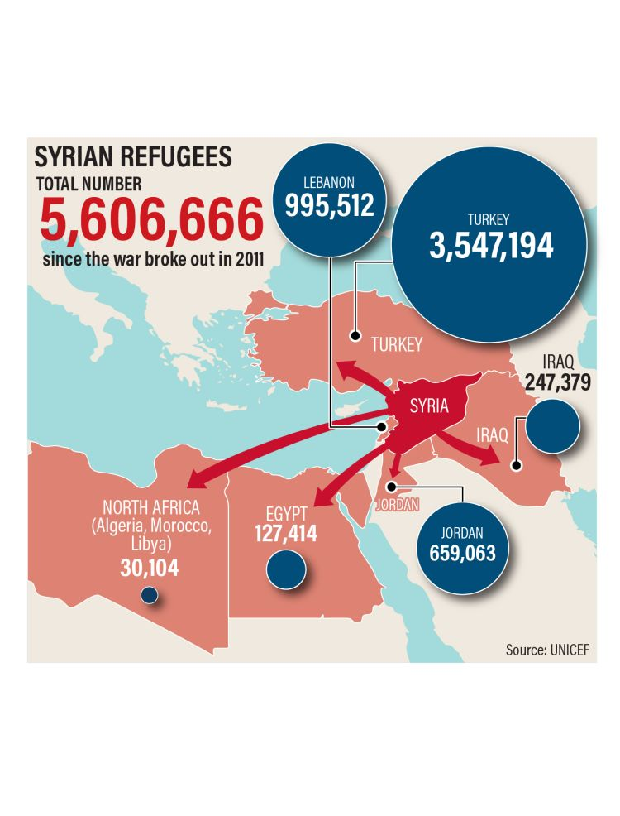

6. Breeding ground for ISIL and shady militias

Since 2014, ISIL has dominated the narrative about extremist groups operating in Syria. The transnational organisation has become a benchmark for extremism in Syria and beyond. But the conflict has produced or provided new space for an array of militias and movements that will no doubt outlive the war in Syria.
As an ethnically and religiously diverse country, Syria has become a natural breeding ground for an assortment of local and foreign militias in which to entrench themselves. They have also benefited from some organic support that magnified and maximised their ability to project power beyond Syria. In other words, these groups will go on to wreak havoc elsewhere after the conflict ends.
In general, militias are shrinking in number across Syria, caused by steady retreats by the rebels since 2013. In one third of Syria, for example, the expulsion of ISIL means that groups who had previously operated in eastern Syria will also have disappeared, because ISIL drove them out in 2014. The same applies in areas taken by the regime, including Homs and Eastern Aleppo.
While those militias no longer exist in such areas, forces that have inherited their territory still contribute to the instability of the region, even if they tend to be viewed as less dangerous. Those include Kurdish militias that Turkey, a neighbour of Syria and a Nato country, regards as an existential national security threat.
A less discussed problematic trend emanating from Syria is the rise of Shiite militias. For the first time in history, Shiite men now travel from their countries to fight in what is framed as a holy war. For now these forces are not seen as a threat, possibly due to the fact that these “mujahideen”, as they call themselves, are under the control of states such as Iran or because they have not engaged in violent campaigns against western countries.
But these criteria will not prove valid for gauging future regional threats because such trends tend to morph into more dangerous phenomena, with continued sectarian hatred, extremism, communal vengeance and polarisation. When extremists become accepted as the defenders of a community or a sect, their extremist ideas become normalised. Worse, some of these forces are celebrated in media and policy circles merely because they are not ISIL, behave differently and have popular support.
The militant Sunni picture in Syria also includes groups that are less notorious than ISIL and Al Qaeda. Those such as Ahrar Al Sham and Jaish Al Islam played a vital role in laying the ideological groundwork for the rise of groups such as ISIL in 2014. Their role involved attempts to outbid their rivals in ISIL and Al Qaeda and, in the process, normalised their extremist narrative. Their opposition to ISIL caused many to see them as less problematic.
Even within known threats, specifically Al Qaeda and ISIL, new trends are emerging. Al Qaeda has organised a new group within Syria, known as Hurras Al Deen, or the Guardians of Religion, acting independently of Jabhat Al Nusra. The new group includes some of the worst of Al Qaeda’s operatives in Syria. Those include several extremists who once built the infrastructure for Al Qaeda in Iraq, the former incarnation of ISIL before 2006.
ISIL has also been trying to make “mainstream” some of the ideas that once alienated its own supporters. Recent revisionist decisions included the idea that a Muslim living “among the infidels” in the West does not become an apostate automatically. Unlike in 2014, when the group wanted people to migrate to Syria and Iraq and join it, the new decision could be an attempt to appeal to sympathisers living abroad. The change in view is one example of many in which the group now seeks to rewrite history.
The Syrian conflict is producing known and unknown threats. Even as most of the front lines are now inactive, except for Eastern Ghouta and Afrin, such threats are far from decreasing. For countries that do not see the conflict as a priority, the by-products of this conflict will continue to affect the whole region.
Hassan HassanColumnist for The National and co-author of the New York Times bestseller ISIS: Inside the Army of Terror and a senior fellow at the Tahrir Institute for Middle East Policy, Washington, DC
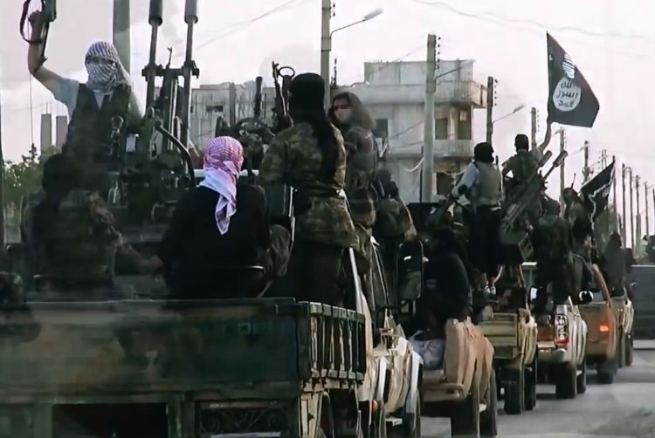
ISIL fighters driving on a street in the northern Syrian city of Homs, allegedly shown in a propaganda video released in March 2014. Above, Syrian pro-government forces set up a checkpoint next to a mural that reads 'Islamic State' in the northern Syrian town of Maskanah (George Ourfalian/AFP)
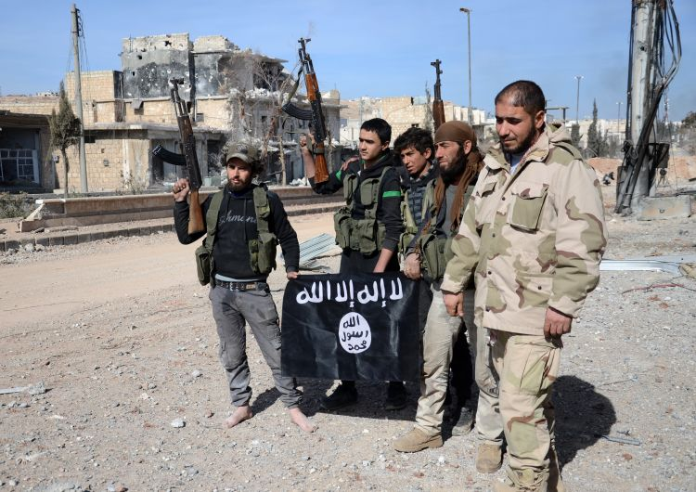
Rebel fighters, part of the Turkey-backed Euphrates Shield alliance, with the ISIL flag as they advance towards Al Bab in February 2017 (Nazeer al-Khatib/AFP)
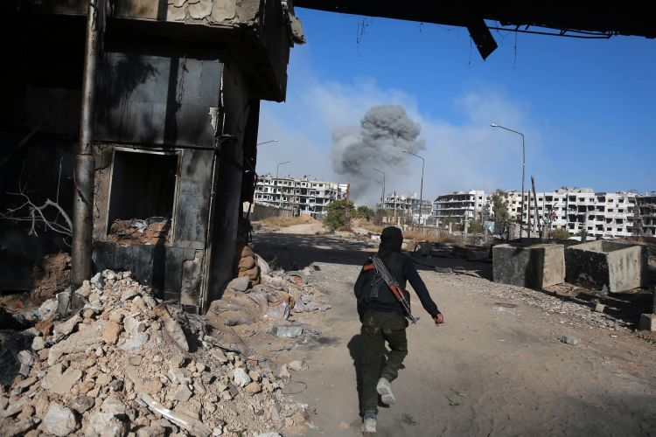
A rebel fighter with the Ahrar Al Sham brigade in the rebel-held town of Harasta, Eastern Ghouta, in November 2017 (Abdulmonam Eassa/AFP)
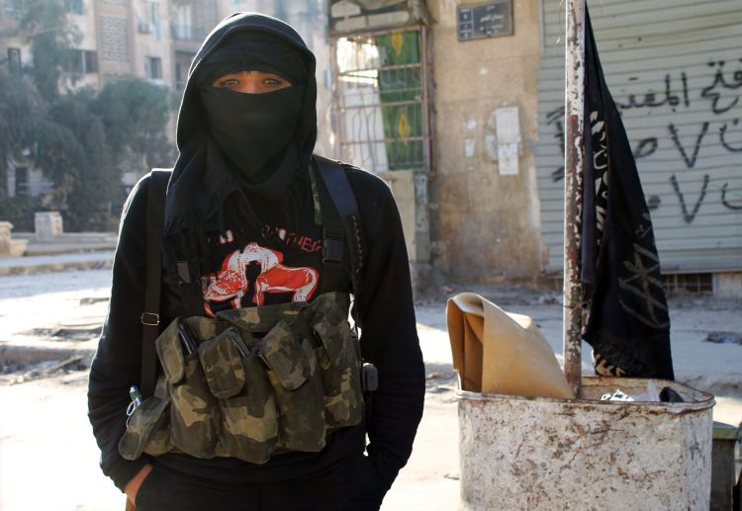
A member of Jabhat Al Nusra in Aleppo in 2014 (Baraa Al-Halabi/AFP)

7. The Middle East's alliances redefined

Iran’s growing footprint in Syria has triggered the revival of a decades-old proposal for a “new regional security architecture” to provide a framework for ending the conflict.
The idea has its roots in the Cold War Helsinki Process that effectively managed a standstill between the two sides. Last month leading officials from Qatar, Iran, Russia and Turkey also endorsed the idea for the Middle East.
But other powers see the idea as unacceptable because it would hand the task of settling regional differences to non-Arab states.
The role of Qatar in this axis is remarkable given its deep involvement in the Syrian conflict. Before the revolution Syria was a Qatari playground. The ruling Al Thani family maintain luxury hunting lodges, including the so-called Mozeh Palace outside Palmyra. Syria's Al Assad family then took it as a personal slight when Qatar poured hundreds of millions of dollars into Al Qaeda-linked groups, notably Jabhat Al Nusra.
Doha’s alignment with Moscow and Tehran adds a new twist to the consequences of the Syrian war for regional diplomacy. Last month Dr Anwar Gargash, the UAE Minister of State for Foreign Affairs, dismissed the idea as unnecessary and undermining the goal of restoring Arab control of the region.
While Al Assad’s control of the Syrian state was the main driver of the conflict until relatively recent times, a new dynamic has emerged: outside forces are scrambling to directly promote their own interests.
The increasing proximity of Israeli and Iranian forces on the battlefield sets the stage for a durable competition for influence between the two sworn rivals, according to Julien Barnes-Dacey, who has followed the war since its inception for the European Council for Foreign Relations.
In his latest research, Mr Barnes-Dacey said the war had moved into a new stage. “The most visible manifestation of this new phase is the deepening conflict pitting Iran, which has entrenched itself across Syria in support of Bashar Al Assad, against the US and Israel, both of which are set on containing Tehran’s widening influence.
“The Trump administration has openly adopted an anti-Iran policy and staked out a long-term, albeit limited, military presence in north-eastern Syria. This US positioning has been accompanied by an increasingly active posture by the Israeli government. Israel has grown ever more worried by the perceived Iranian threat on its north-eastern border and has intensified its campaign of military strikes.”
'The most visible manifestation of this new phase is the deepening conflict pitting Iran, which has entrenched itself across Syria in support of Bashar Al Assad, against the US and Israel'Julien Barnes-Dacey
Tilt the kaleidoscope around the battlefield and another flashpoint stands out for Michael Stephens of the Royal United Services Institute. Turkey has sent in its forces against US-trained fighters as Ankara seeks to break-up Kurdish enclaves in northern Syria.
“Absent of any real strategy to solve the conflict, the game switched to creating as much leverage as possible in anticipation of an end-state in Syria,” Mr Stevens reports. “For Washington and Ankara, creating leverage has meant carving out regions of Syria with a light military footprint and reliable partners on the ground, which both have done with relative success. The problem was not so much the tactic, (both the US and Turkey will now be guaranteed a seat at the table when Syria’s war ends), but the choice of partners.”
Meanwhile the eclipse of ISIL as a territorial force has changed the dynamics within the international coalition, according to US experts, Melissa Dalton and Hijab Shah at the Centre for Strategic and International Studies.
“As the [Global] Coalition shifts to a local governance and civilian-led stabilisation approach, overlapping tensions and interests of competitors, adversaries and allies in Syria pose further challenges to US interests in consolidating hard-fought gains by local US partners and US forces,” the pair wrote in the Washington publication, The Hill. “US strategy in Syria hinges on leveraging relative strength from the periphery to the centre, to pressure Al Assad to negotiate a political outcome to the conflict.”
They say that to build up its allies in Syria, Washington needs Turkey to stop attacking its friends and to allow a flood of aid for reconstruction into border zones.
European powers have put their faith in a deal with Russia to end bloodshed by forcing Al Assad to sign a peace agreement that leads to his departure from power.
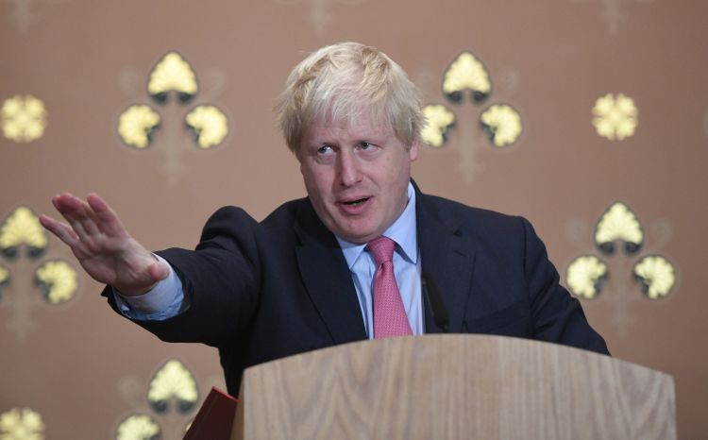
Boris Johnson, the British Foreign Secretary, summed up this route to peace when speaking in the House of Commons last month. “There is only one way forward, which is for the Russians to put pressure on the Assad regime to get to the negotiating table,” he said. “I think that view may at last be gaining ground in Russia, because the Kremlin has no easy way out of this morass.
“It is up to the Russians to deliver their client.”
Those comments now look outdated. With so much outside meddling conducted across an ever-widening front, it is naive to assume a change of heart in the Kremlin would end the fighting.
Damien McElroyLondon bureau chief of The National
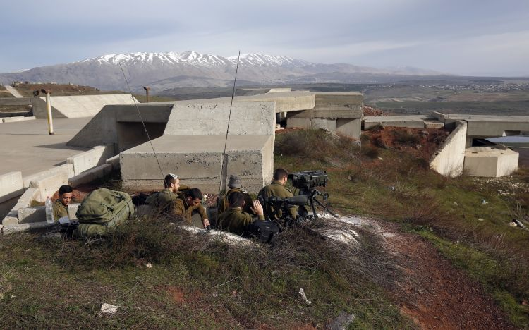
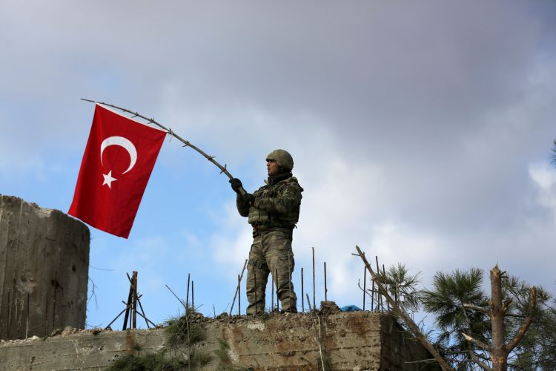

8. The failure of international politics will affect us all

What has happened in Syria has not stayed there. An internal conflict featuring war crimes and crimes against humanity has created a humanitarian abomination and geopolitical catastrophe spilling into Syria’s neighbourhood and far beyond. The international system has been powerless to stop the slaughter or its consequences.
How many UN Security Council resolutions have demanded ceasefires, an end to the targeting of civilians, releasing detainees and lifting sieges? All have been ignored by the regime of Bashar Al Assad. Others have been vetoed by Russia and China.
How many reports have been issued by the Independent International Commission of Inquiry detailing war crimes inflicted on civilians in Syria, mainly by the country’s "government"? How many international NGOs have begged the Security Council to do its duty and protect civilians? How often have senior UN officials condemned the mass homicidal actions of a member state?
How many UN special envoys have tried desperately, with no useful external support, to tamp down the slaughter and get the parties to negotiate? When has the Assad regime ever complied?
How many western politicians, eager to pose as heroic opponents of government mass murder, have proclaimed “Never Again”? How many have lifted a finger to protect Syrian children and their parents from a murderous government?
Some say that the rules-based, international order is under attack. Some heap blame on the current American president. But who launched punitive military strikes after the Assad regime unleashed a sarin nerve agent assault on defenceless civilians? (Hint: it was not a Nobel Peace Prize laureate.)
President Barack Obama consistently averted his gaze from the slaughter in Syria. He feared he might complicate the quest for a nuclear deal with one of the accessories. The price for achieving a presumptive "legacy" jewel in the crown was cynically and gratuitously exacted of Syrians. But Iran wanted the deal. It did not have to be appeased with the lives of Syrians.
Russia and Iran seek to restore Al Assad in all of Syria. They support fully the regime’s strategy of state terror. They take part in it. They hope to compel western-financed reconstruction through demographic blackmail. They appreciate their client’s illegitimacy. They know that Assad Syria is a ruined Syria: a place that will haemorrhage humanity and incubate extremism. They hope to clot the bleeding by forcing a fearful Europe to fix what they and their client have broken.
Without American leadership, there is no effective response to what Russia, the regime and Iran are doing. Russia will permanently neutralise the Security Council. European politicos will wring their hands, fearing another tsunami of frightened refugees. Al Assad will continue to do his worst with Iranian-led mercenaries supplementing his broken army. But the American trumpet is uncertain.
By making Al Assad’s use of highly toxic chemical weapons the sole trigger for protective strikes against regime targets, the US unintentionally gives him a green light to kill as he wishes with everything else at his disposal. And the man who considers Syria to be his family farm has taken full advantage. Eastern Ghouta is Syria’s Guernica.
American officials condemn mass homicide in Syria and call on the international community to do something. Yet they do so knowing one central truth: if the US does not end the free ride for civilian slaughter in Syria, no one else will. Other dictators around the world watch with great interest.
The geopolitical consequences of mass murder in Syria cannot be contained at the scene of the crime. Without American leadership, the international system inevitably enables bad behaviour and ensures catastrophic results.
Frederic C HofDirector of the Rafik Hariri Center for the Middle East at the Atlantic Council in Washington, DC
Credits
Editors: Mo Gannon, Joe Jenkins, Arthur MacMillan, Stephen Nelmes, Paul Stafford
Photo editors: Jake Badger, Rob Gurdebeke
Graphics: Roy Cooper, Ramon Penas
Multimedia: Emmanuel Samoglou

