Bin Farhan to Asharq Al-Awsat: The agreement with Iran is evidence of the common desire to resolve differences through dialogue
Saudi foreign minister said he hoped China's sponsorship of the deal would contribute to strengthening common security in the region
Monday - 21 Shaaban 1444 AH - 13 March 2023 AD Issue No. [ 16176]
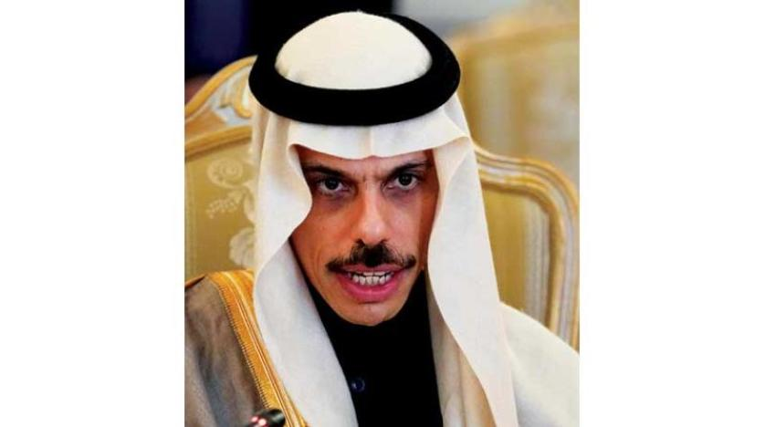
Prince Faisal bin Farhan, Saudi Foreign Minister (AFP)
London: Zaid Bin Kami
Saudi Foreign Minister Prince Faisal bin Farhan said that the Saudi-Iranian agreement to restore diplomatic relations confirms the common desire of the two sides "to resolve differences through communication and dialogue." But he stressed that this "does not mean that all outstanding differences between the two countries have been resolved."
Riyadh and Tehran agreed in Beijing on Friday to resume ties severed since 2016 and reopen embassies within two months.
The Saudi minister told Asharq Al-Awsat, in his first interview since the announcement, that he looks forward to meeting his Iranian counterpart soon based on what has been agreed. He added: "We are preparing to resume diplomatic relations between our two countries in the next two months, and it is normal in the future to exchange visits."
On his recent visit to Kiev and Moscow and talk about Saudi mediation to stop the Ukrainian-Russian war, Ibn Farhan stressed that Saudi Arabia is "ready to exert good offices and work with the two countries in order to reach a political solution that ends the crisis, stops the fighting and saves lives," stressing the need to stop the escalation that has harmed the two countries and the security of Europe and weakened the level of international cooperation. Following is the text of the interview:
Q: After the announcement that Saudi Arabia and Iran have reached an agreement that includes agreeing to resume diplomatic relations and reopen their embassies within a maximum period of two months, what is the direct Saudi interest in such an agreement? Does the agreement usher in a new phase in the region at the political, economic and regional levels?
A: The origin of international relations is the existence of diplomatic relations between States, which is reinforced in the case of two neighbouring States the size of the Kingdom of Saudi Arabia and the Republic of Iran, which share several common religious, cultural, historical and civilizational ties.
This agreement, under the auspices and mediation of the People's Republic of China, came after several rounds of talks over the past two years in the sisterly Republic of Iraq and the Sultanate of Oman. The Kingdom of Saudi Arabia is continuing on the path of calm and de-escalation, sensing its role and responsibility in promoting regional and international security and stability.
Our reaching this agreement, which will lead to the resumption of political relations, does not mean that we have resolved all outstanding differences between our two countries, but rather it is evidence of our common desire to resolve them through communication and dialogue through peaceful means and diplomatic tools. We in the Kingdom hope to open a new page with Iran and enhance the prospects for cooperation that will reflect positively on the consolidation of security and stability and advance the wheels of development and prosperity, not only in our two countries, but in the region as a whole.
Q: When will you hold your next meeting with the Foreign Minister of Iran to activate the agreement and arrange the exchange of ambassadors? And can we see you in Tehran soon?
A: I look forward to meeting with the Foreign Minister of Iran soon based on what has been agreed, and we will prepare to resume diplomatic relations between our two countries within the next two months. In the future, it is normal to exchange visits.
Q: Despite Riyadh and Tehran's assertion in the tripartite statement signed with Beijing that the issue of "respecting the sovereignty of countries and non-interference in their affairs" was questioned by Washington, so did the agreement include conditions on non-interference in internal affairs, and do you think that Iran will respect this clause?
A: One of the most important requirements for opening a new page with Iran is to abide by what has been agreed upon between the two parties and to the contents of the Saudi-Iranian-Chinese tripartite statement, and there is no doubt that the interest of our two countries and the region lies in activating the paths of cooperation and joint coordination and focusing on development priorities rather than considerations of hegemony, in a way that leads to the realization of the aspirations and hopes of our peoples and the young generations of our region for a better future in which security, stability and prosperity prevail. We hope that the Iranian side shares the same goals and aspirations, and we look forward to working with them in the past to achieve it.
Q: Iran has long faced multiple crises, from the collapse of nuclear negotiations to the internal situation that is giving birth to crisis after crisis, as well as a host of pressing economic and social concerns. But some, especially in the West, believe that this new agreement may represent a lifeline for the Iranian regime at a critical time. What do you think?
A: I will not talk about most of what the question addresses, as it is an internal Iranian affair, but what I can say is that Iran is a neighboring country whose stability and development are in the interest of the stability and development of the region as a whole. We in Saudi Arabia wish nothing but the best. As for Iran's continued development of its nuclear capabilities, that undoubtedly worries us, and we reiterate our call for the Gulf region and the Middle East to be free of weapons of mass destruction. We call on Iran to commit to implementing its nuclear commitments and to intensify its cooperation with the IAEA, and we will continue to work with allies and friends to ensure this.
Q: Why was China in particular the mediator and not any other country?
A: As stated in the joint statement, Saudi Arabia welcomed the initiative put forward by His Excellency the President of the People's Republic of China, Mr. Xi Jinping, and interacted with it as an extension and continuation of the negotiations that have been taking place with the Iranian side for two years. As is well known, China enjoys positive relations with both sides, which has contributed to bringing views closer and highlighting the Kingdom's legitimate concerns.
We hope that China's sponsorship of the agreement will contribute to promoting coexistence and common security in our region and good-neighbourly relations among countries. The three countries have a common interest in creating a regional environment of peace, security and stability, so that they can work to build and develop regional and international partnerships through which to provide the requirements for development and economic prosperity for the peoples and States of the region.
Q: You put forward in Moscow an initiative to end the Ukrainian conflict. Can you shed more light on your diplomatic endeavors there, specifically the extent to which the parties involved accept any Saudi role, have you made progress in this area, and are you optimistic about success?
A: We were and remain ready to provide good offices and work with both countries to reach a political solution that ends the crisis, stops the fighting and saves lives. Crown Prince Mohammed bin Salman's efforts to complete a prisoner exchange deal between the two parties succeeded in completing a prisoner exchange deal, which resulted in the return of citizens of ten countries to their countries. The Kingdom has focused on highlighting the importance of meeting urgent humanitarian needs that have been affected by the continuation of the war, and our humanitarian assistance to Ukraine has come in response. The situation requires the parties, and the rest of the international community, to stop the dangerous escalation that has harmed both countries and the security of Europe and weakened the level of international cooperation.

